COVID-19 POLICY

Lighthouse Dental Practice has put Policies and Protocols in place to reduce the risk of a member of staff or patient contracting Covid-19. All Staff have been given training with the basic hand hygiene, Coronavirus, an updated Infection control and decontamination course and much more from ISOPHARM to equip the team with the knowledge and understanding of the said virus. We continue to keep updated with the latest guidelines and will continuously update our policies and protocols where required and train our staff as necessary.

Details of Covid-19
It is transmitted primarily through droplets of saliva or nasal discharge when a person coughs or sneezes who is infected with COVID-19. The droplets from that person are then in the air and can land on a surface that you touch.

How to Protect yourself
- Wear a face mask when in public.
- Refrain from touching your face with unwashed hands.
- Sanitise/ wash your hands as you enter/leave a public place.
- Ensure if you need to cough you do so into the crook of your elbow or into a tissue.
- Practice social distancing.
- Avoid unnecessary travel.
The symptoms of COVID-19 affect people in varying degrees, most people who are infected will develop mild to moderate symptoms and recover at home.
However, people over 60 and people with underlying medical conditions have a higher risk of severe symptoms and have a higher chance of death from the disease.

Main symptoms:
- A high temperature- this means you feel hot to touch on your chest or back (you do not need to measure your temperature)
- A new continuous cough- this means coughing a lot more than an hour, or 3 or more coughing episodes in 24 hours (if you usually have a cough, it may be worse than usual)
- A loss or change to your sense of smell or taste- this means you’ve noticed you cannot smell or taste anything, or things smell or taste different to normal.
Symptoms will usually develop 5-11 days after exposure and can last 5-6 days.

WHAT TO DO IF YOU DEVELOP SYMPTOMS:
If a staff member develops symptoms of COVID-19 then you must NOT go into work.
You must inform your line manager and self-isolate at home for 10 days from as soon as the symptoms start.
If their condition worsens then you must call the NHS 119 service. They will be able to book you a test at the nearest centre.
If other staff members fall into the high-risk category then they should be risk assessed in relation to their deployment.
Any staff members that are vulnerable or extremely vulnerable including people they live with should have the support of their employers to enable them to follow government guidance on shielding and social distancing.

If you come into contact with someone who has symptoms or tested positive, or been told to self isolate by the NHS app, you will be required to self-isolate as recommended by the government. Whether you have a test and its negative, self-isolation remains the same.
Please note the app must be switched off when you are inside the practice (This has been a request from NHS England)

The WHO recommends that washing your hands properly should take the same amount of time as singing “Happy Birthday” twice.
You should follow the steps below to wash your hands effectively:
- Wet hands with water
- Apply enough soap to cover all hand surfaces
- Rub hands palm to palm
- Right palm over left dorsum with interlaced fingers
- Palm to palm with fingers interlaced
- Backs of fingers to opposing palms with fingers interlocked
- Rotational rubbing of left thumb clasped in right palm and vice versa
- Rotational rubbing, backwards and forwards with clasped fingers of the right hand in left palm and vice versa
- Rinse hands with water,
Dry thoroughly with a single-use towel,
Use a towel to turn off the faucet.

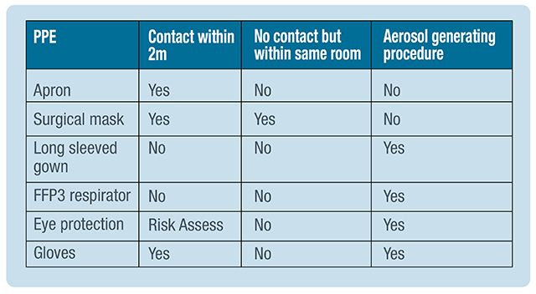
Before donning PPE the healthcare worker should ensure they are hydrated, their hair is tied back, jewellery has been removed and that the PPE needed is the correct size and available for use.

It is imperative that hands are washed before donning any PPE.

The following steps must be followed:
- Put on the long-sleeved fluid repellent disposable gown and fasten around the waist and neck.
- Apply respirator mask which must have been fit tested. The upper straps must be positioned on the crown of the head above the ears and the lower strap at the nape of the neck. Ensure that the respirator is moulded around the bridge of the nose with both hands to ensure a good seal.
- Apply face visor and adjust headband where necessary.
- Apply gloves and ensure each glove is covering the cuff of the gown.

The following steps must be followed to remove PPE:
- Grasp the outside of the glove with the opposite gloved hand and peel off. Then slide the fingers of the ungloved hand under the remaining gloves at wrist level and peel off – discard.
- Unfasten the necktie and waist tie then pull gown away from neck and shoulders only touching the inside of the gown. Now turn the gown inside out and fold or roll into a bundle and discard.
- Remove using both hands to handle and pull away from the face from behind and discard. Before moving onto stage 4 Wash hands.
- To remove a respirator mask, lean forward and reach to the back of your head with both hands and find the bottom strap and lift it to the top strap. Then lift both straps over the top of your head and let the respirator fall away from your face and discard.
- WASH YOUR HANDS.

Constantly being reviewed by management

