SOP

Update 24.11.2021

Respiratory guidance has been published by PHE and the following is now the recommended pathway for patients, and there for the team, going forwards. Local risk assessment is also required to fulfil the requirement of the health and safety at work act 1974 which can be read after the appendices. The guidance can be read in full here:

https://www.gov.uk/government/publications/wuhan-novel-coronavirus-infection-prevention-and-control/covid-19-infection-prevention-and-control-dental-appendix

What has changed?

The low, medium and high risk pathways have been removed. Patients will now fall into one of two pre-screening pathways – non respiratory or respiratory thus:

Patients who are fit and well/ “non-respiratory pathway” are to be seen as per the pre Covid protocols
Face coverings to be worn in the practice during the winter 21/22 season
No FFP or fallow time required for fit and well patients

Any patients reporting respiratory symptoms/”respiratory pathway” are preferably to be deferred or, if urgent, to be seen as per Covid IPC protocols i.e. FFP and fallow commensurate with ACH.

Pre-screening patients

This will continue as per the previous guidance to ensure that any patients attending are experiencing no respiratory illness when they attend. An example of pre-screening questions can be found at Appendix 1 – ideally this will be done a day prior to the appointment via phone, email or text for example and also when the patient arrives.

If patients report they are fit and well then ALL pre Covid protocols are followed:
Face covering in the building,
No FFP
No fallow
Aprons/gowns can be worn if splash is expected
Normal pre Covid cleaning

If patients report that they are not well with respiratory symptoms, then:
Ideally treatment should be deferred
If the patient requires urgent treatment:
Then the respiratory pathway should be followed thus:
FRSM/surgical mask in the building
FFP3
Fallow commensurate with ACH
Gowns/aprons to cover uniform.

How to choose the respiratory pathway algorithm is at Appendix 2

Lighthouse Dental Practice will carry out individual Risk assessments during these times.

PPE and RPE (Respiratory Protective Equipment)

A surgical mask or FRSM is worn as per usual for all procedures and changed after each patient.

RPE of FFP can be worn if the team decides they wish to or if local risk assessment shows that this is required.

Testing

Asymptomatic staff must self-test twice per week as per England’s guidance on asymptomatic testing. Results must be reported on the NHS portal. Test kits can be ordered here: https://www.gov.uk/order-coronavirus-rapid-lateral-flow-tests

Patients do not require testing prior to their appointment

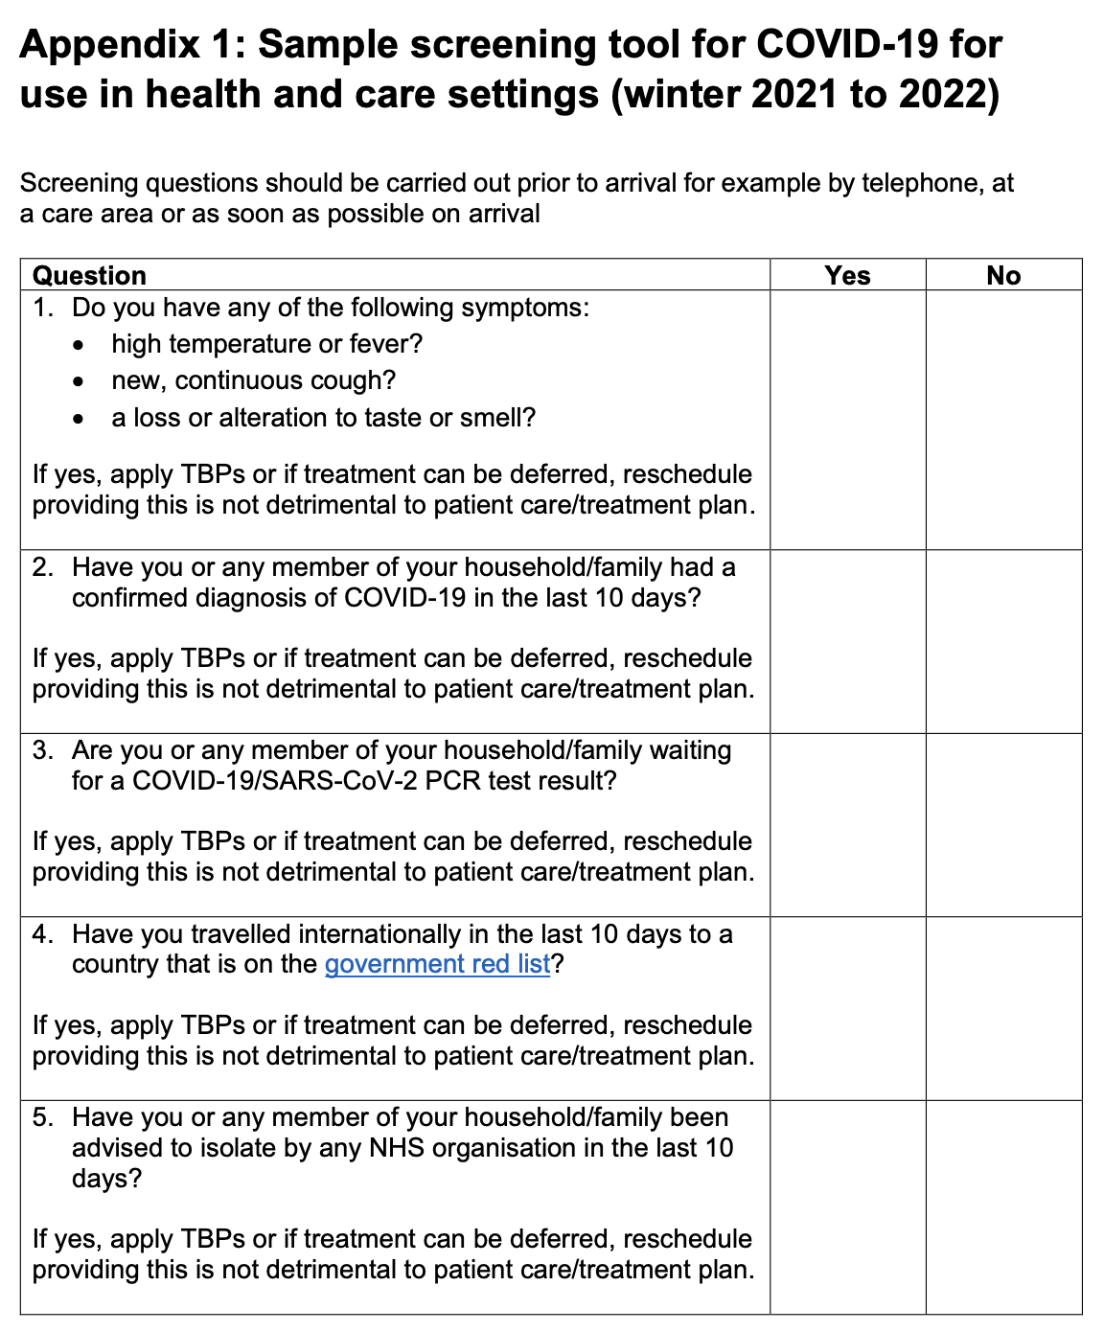

Appendix 2

Choosing the respiratory pathways
